**Basics of Corporate Finance**

**MODULE – BASICS OF CORPORATE FINANCE**

**Corporate finance** is an area of finance that deals with **sources of funding**, the **capital structure** of corporations, the actions that managers take to **increase the value** of the firm to the shareholders, and the tools and analyses used to allocate financial resources. The primary goal of corporate finance is to **maximise the shareholder’s value**.

Any corporate finance takes three important decisions:

* ***Investment decisions***: These involve analysing the profitability of an investment opportunity.
* ***Financing decisions***: These relate to decisions involving the identification of the sources of finance; a firm can raise finance through either debt or equity.
* ***Dividend decisions***: These decisions involve returning money to the shareholders in case the business entity fails to identify a profitable investment opportunity.

In this course, we will not be covering dividend decision as that is beyond the scope of this course.

Investment Projects can be categorised as:

* **Mutually exclusive projects**, wherein only one among the given options can be selected due to financial or some other constraints; and
* **Independent projects**, wherein any number of projects can be selected from the given options, provided they are profitable.

**Time Value of Money**

* ***Present value***: This refers to the current value of money.
* ***Future value***: This refers to the value of money after a certain period, considering the rate of interest.

Relationship between Present Value and Future Value:

*If compounding is done annually,*

**Future Value = Present Value (1+ R)T**

where

R: Rate of interest;

T: Time period;

*If compounding is done at some other frequency,*

**Future Value = Present Value (1+ R/N)T*N**

where

R: Rate of interest;

T: Time period;

N: Number of compounding intervals per time period.

Excel Function for calculating Present Value

=PV(rate, nper, pmt, fv, type)

Here,

* rate: effective rate of return per payment period
* nper: number of payment periods
* pmt: The recurring cash flow
* fv: Future value of the cash flow
* type: 0 - if the payment is made at the end of the period, and 1 - if the payment is made at the beginning of the period.

Compounding and Discounting

* The process of converting present value to future value is termed ***Compounding***.
* The process of converting future value to present value is termed ***Discounting***.

Types of Investments

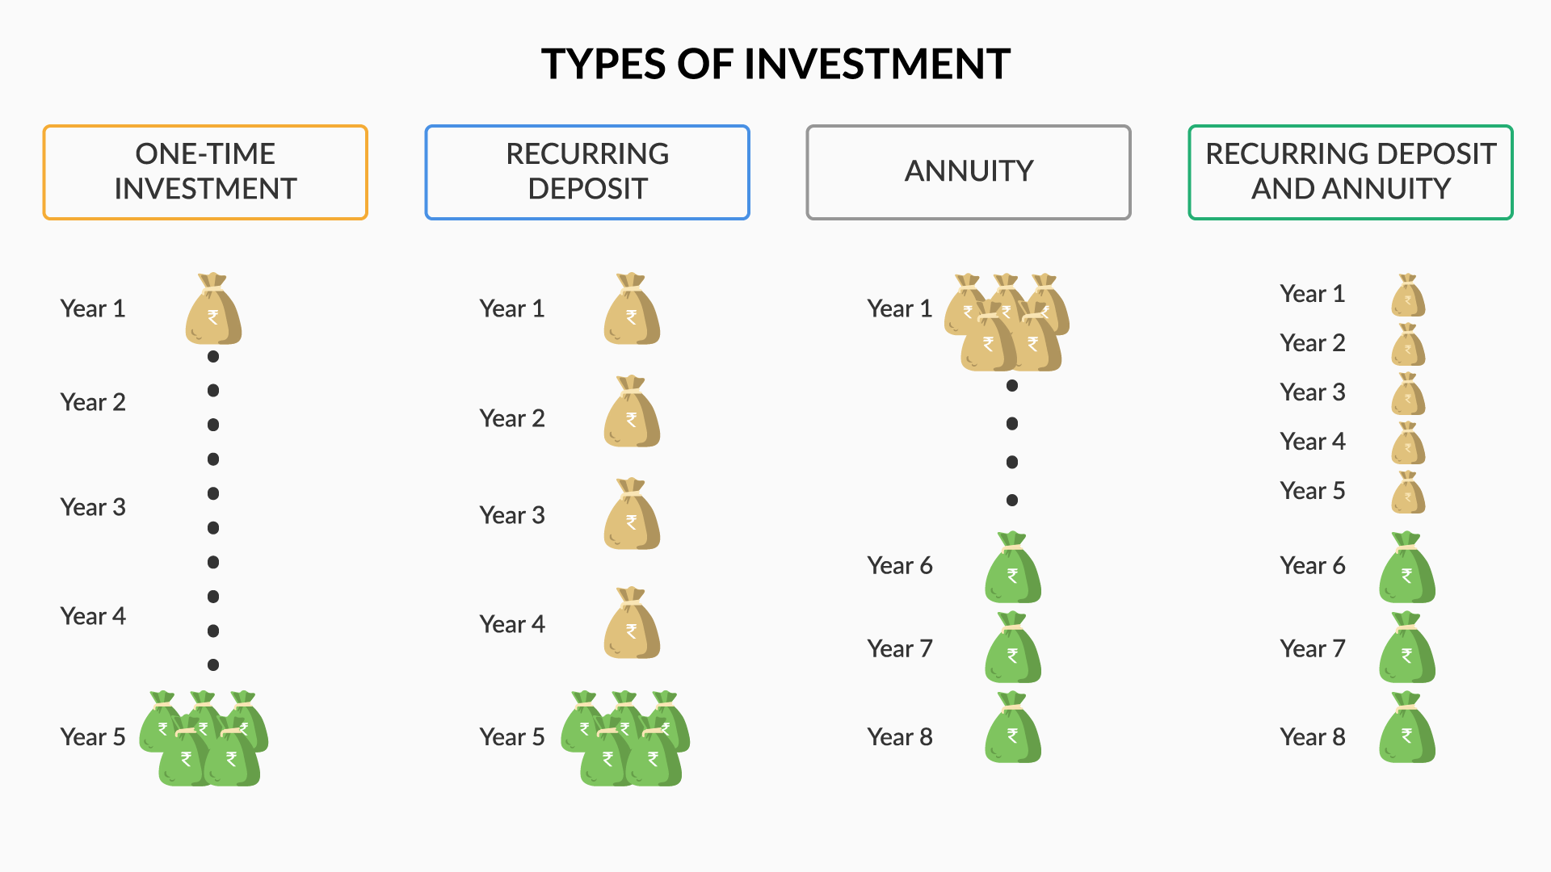

* ***One-time Investment***: Invested once only at the beginning of the investment period to generate a particular amount of corpus at the end of a specified period.
* ***Recurring Deposit***: Invested every month/quarter/half-yearly/annually/or any other frequency to generate a particular amount of corpus at the end of a specified period.
* ***Annuity***: Invested once as a lump-sum amount to keep receiving a fixed amount monthly/quarterly/ or any other frequency after a specific period and for a specific period.
* ***Recurring Deposit and Annuity***: Investments done on a particular frequency periods to generate a corpus by the end of a specified term which corpus will then generate fixed monthly or periodic payments.

**Rate of Return**

Money earns interest over time, which is defined as the rate of return.

Two major types of rate of return:

* **Real rate**: This is the rate of return that you receive or expect to receive upon your investment.
* **Nominal rate**: The rate of return accounted for the expected change in inflation.

Relation between the two is:

**Nominal Rate = Real rate + Expected Inflation**

***Another factor*** that affects the rate of return is the risk involved; if a lender perceives an investment as a risky opportunity, he will be willing to invest only if the returns are higher than those from other investment options. So, the higher the risk, the higher is the rate of return. On the basis of this, we have two types of rates of return:

* **Risk-free return**: This is the guaranteed return that an investor can expect to get on his investment.
* **Risk-adjusted discount rate**: This is the rate of return that is adjusted for the risk premium.

The relation between the two is:

**Risk-adjusted discount rate = Risk-free rate + Risk premium**

*Risk free premium will remain same for all the investments (for the purpose of solving questions. Not in actual life)*

**MODULE – PROJECT EVALUATION TECHNIQUES - I**

**Multiple Cash Flows – I**

Recurring income from the investments is termed as multiple cash flows.

If an investment of Rs 50L, say into a real estate were to generate 5L annually for 3 years and also I am expecting to sell off the property for Rs 60L at the end of the Year 3, then its current value can be calculated as :

P.V = Y1 + Y2 + Y3

|  |  |  |
| --- | --- | --- |
| Y1 | Y2 | Y3 |
| 5/(1+r) | 5/(1+r)2 | 65/(1+r)3 |

Hence, above the cash flows need to be discounted to their respective present values.

**Perpetuity**: If an investment was to generate cash flows for an indefinite period of time, then such a cash flow that continues indefinitely is known as perpetuity.

**Present value of a perpetuity = C/R**

Where,

* C denotes the recurring cash inflow, and
* R denotes the rate of return.

**Multiple Cash Flows – II**

**Annuity**: A cash flow that is generated for a fixed period of time is known as an annuity.

**Present Value of an annuity is C* [(1/R) – (1/R(1+R)N)]**

The term **[(1/R) – (1/R(1+R)N)]** is called as **Annuity Factor**.

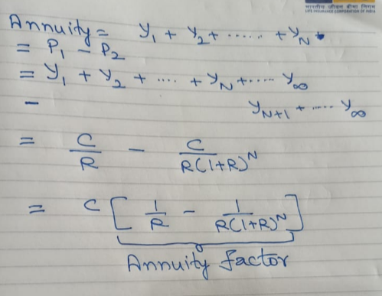

Annuities are divided into the following two types:

* **Ordinary annuity**: Here, cash flows are received/paid at the end of each time period.
* **Annuity due**: Here, cash flows are received/paid at the beginning of each time period.

In an ordinary annuity, the initial cash flow is also discounted, so to convert it into an annuity due, all the cash flows need to be compounded by one year.

So, the above formula will hold true for an Ordinary annuity, but for an Annuity due, the present value can be calculated by multiplying the above formula by (1+R).

So,

**Present Value of an Ordinary Annuity = C* [(1/R) – (1/R(1+R)N)]**

**Present Value of an Annuity Due = C* [(1/R) – (1/R(1+R)N)]*(1+R)**

Future Value of Annuity Due = P.V of Annuity Due * (1+R)N

Thus,

**Future Value of Ordinary Annuity = C * [ ((1+R)N -1)/R]**

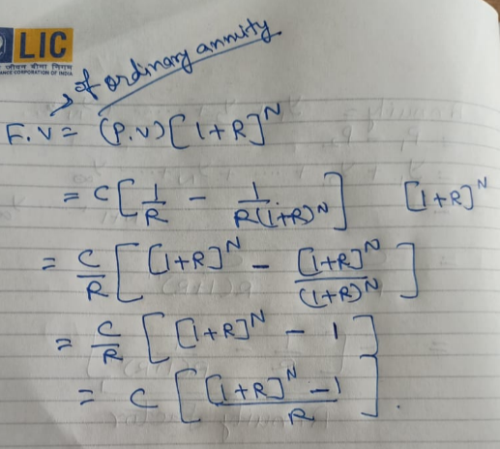

**Future Value of Annuity Due= C * [ ((1+R)N -1)/R]*(1+R)**

**Project Evaluation Techniques**

* Net Present Value
* Payback Period and Discounted Payback Period
* Internal Rate of Return
* Profitability Index

**Net Present Value**

**Net Present Value = Present value of all cash outflows + Present value of all cash inflows.**

Outflows will be negative, Inflows will be positive.

Any project having a positive NPV can be accepted.

**Payback Period**

Technique of analysing the time period to recover the initial investment is known as the payback period.

This technique has some drawbacks, such as follows:

* It ignores the cash flows after the payback period.
* It does not consider the time value of money.

The payback period method can be modified by discounting the cash flows. This technique is known as ***discounted payback period*** method.

Normal payback doesn’t even consider discounted values (doesn’t consider time value of money) which discounted payback period does.

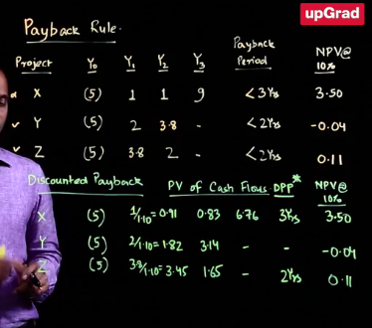

**MODULE – PROJECT EVALUATION TECHNIQUES – II**

**Internal Rate of Return**

Rate of return at which the present value of cash outflows is equal to the present value of cash inflows is known as the Internal Rate of Return.

Assume,

|  |  |  |
| --- | --- | --- |
| Y0 | Y1 | Y2 |
| -100 | 60 | 60 |

Here, for the value of ‘r’ for which cash outflow (100) will be equal to cash inflow (P.V of Y1 inflows + P.V of Y2 inflow).

100 = 60(1+r) + 60(1+r)2

That will be the Internal Rate of Return.

The acceptable rate of return for us, we call it as a **Hurdle rate (also called discounted rate)**. e.g., for a risky investment, we might want to have a hurdle rate of 15%.

So,

**If IRR >= Hurdle Rate 🡪Accept.**

**If IRR < Hurdle Rate 🡪Reject.**

Relation between IRR and NPV

There is an inverse relationship between IRR and NPV. Also, mind that while **NPV is an absolute measure(it is the value added in terms of money), IRR is a relative measure**(it is the rate of return of the project).

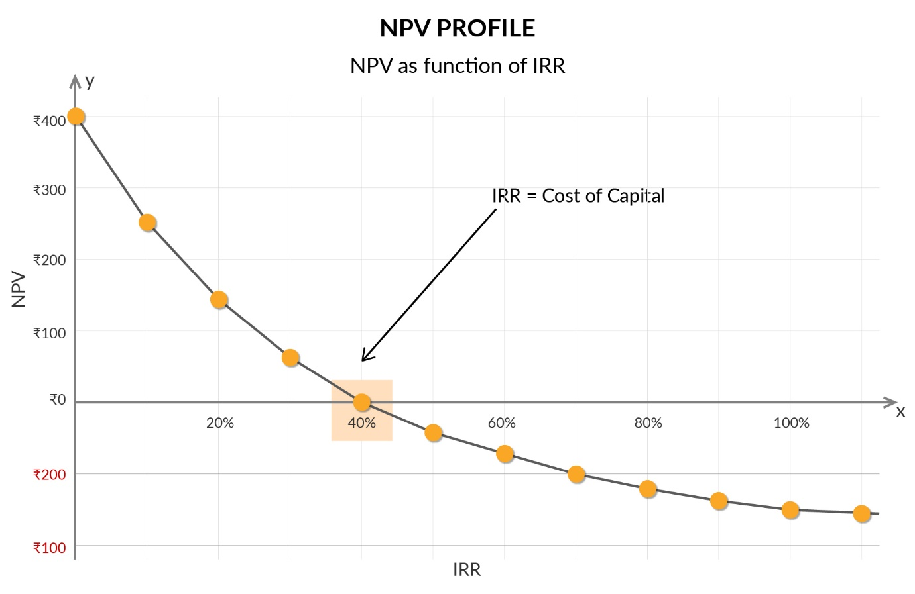

**Pitfalls of IRR-I**

* Lending or Borrowing
* Multiple Rates of Return
* Mutually Exclusive Projects
* Multiple Opportunity Cost of Capital

Lending or Borrowing

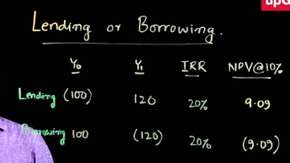

The IRR rule changes depending on whether you are borrowing or lending:

* Borrowing: IRR should be lower than hurdle rate.
* Lending(Investing): IRR should be higher than hurdle rate.

Multiple Rates of Return

If the sign of a cash flow changes more than once, there can be two values of the IRR. In such a case, you need to find the NPV using the hurdle rate; if NPV is positive, you may select the project.

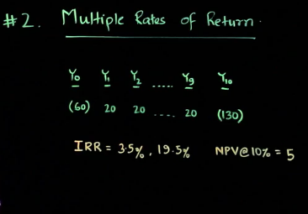

Mutually exclusive projects

Suppose you have two options to invest in: In the first option, you can invest ₹100 and get ₹200 a year later, and in the second, you can invest ₹1,000 and get ₹1,500 a year later. Which option will you choose?

If you apply the IRR technique, you will choose to invest in the first option, as it has a 100% return, while the second has a 50% return. But what this technique fails to consider is the absolute value of money: In the first case, you will get an additional ₹100 only, while in the second case, you will get ₹500.

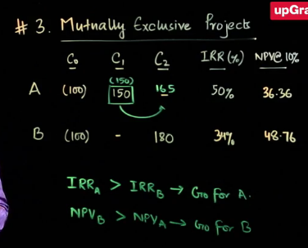

*Note that in case of A, we are assuming that we would re-invest 150 (so, net cashflow is 0)*

Multiple Opportunity Cost of Capital

Multiple Opportunity Cost of Capital means *Multiple Hurdle Rates*.

Different cashflows (C0, C1, C2,…., Cn) could have different hurdle rates (risk rates) (r1, r2, r3,…., rn).

If we employ NPV, we can very well go ahead and calculate it and on the basis of that we can take a decision whether to invest or not.



But we can’t deicide the same on the basis of IRR, as there could very well be the hurdle rates which are above the IRR and also the hurdle rates which are below the IRR.

**Profitability Index**

Considering the capital constraints, a business has to select only a combination of the most profitable projects to maximise the returns. This is called as **capital rationing**.

So, to select from independent projects, firms or entities rank the projects using the technique of profitability index and, based on the ranking and capital availability, select the most profitable projects.

**Profitability Index = Net Present Value / Initial Investment**

**MODULE – CASE STUDY: PROJECT EVALUATION**

How to estimate the different elements of cash flows:

* **Revenue**: Considering the incremental revenue, if the project affects the revenue of an existing project, that has to be considered as a reduction.
* **Cost**: Similar to revenue, the incremental cost needs to be considered. The two major components of cost are fixed cost and variable cost.
* **Working capital**: Any change in the working capital will also be part of the cash flow. At the end of the project, the working capital will be recovered.

**TBD again**

**MODULE – ADVANCED PROJECT EVALUATION**

**How to arrive at Cash Flows for a Project?**

Project Evaluation using the NPV Rule

There are four basic rules of cash flows that should be kept in mind while estimating cash flows.

1. Only and only Cash Flow is relevant.
2. Incremental Cash Flow is relevant.
3. Consistent treatment of inflation.
4. Separate investment and financing decision

Only and only Cash Flow is relevant:

Reported Income / Accounted Income are not same as Cash Flows.

There are 2 essential differences between income and cash flows:

* Capex Depreciation
* Working Capital

CAPEX Depreciation

Depreciation is a non-cash expense for a company, although while calculating the accounting income, depreciation is subtracted as an expense from the revenue owing to the accrual concept to arrive at the PAT (Profit after Tax).

Cash flows take into consideration only the actual cash inflow and outflow from the company.

This implies that depreciation should not be taken as an expenditure while estimating a cash flow. Therefore, depreciation is added back to PAT to arrive at cash flow.

Net Income + Depreciation = Cash Flow (All numbers in positive)

1000 + 2000 = 3000

Working Capital

Working capital (NWC) is the difference between a company's current assets, such as cash, accounts receivable (customers' unpaid bills) and inventories of raw materials and finished goods, and its current liabilities, such as accounts payable.

Working Capital = Current Assets – Current Liabilities

Receivables as well as Inventory is treated as an asset. But if we don’t have money at hand (receivable) we can’t call it cashflow till we receive it. Similarly, if we have already paid for an inventory, cash flow has already been in negative.

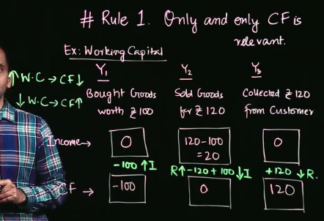

* **Assets↑ or Liability↓ = CF↓**
* **Assets↓ or Liability↑ = CF↑**
* **Working Capital↑ = CF↓**
* **Working Capital↓ = CF↑**

**Should you consider incremental cash flow?**

Incremental Cash Flow is relevant

* Incidental Cash Flows
* Opportunity Cost
* Forget Sunk Cost
* Remember salvage value

Incidental Cash Flows

Say I come up with a product which will also have an effect (positive or negative) on my existing product, then in this case, I will need to take into account the effect on cashflow on exiting product also in addition to the cashflow on the new product. Note that such effects can be cannibalising as well as favourable. So, collateral benefits and collateral costs need to be considered. This is the case of an incidental cash flow. While these are not explicit cashflows and are not very evident, they need to be incorporated when we evaluate a project.

Apart from the normal cash flows, incidental cash flows are also required to be accounted for.

Opportunity Cost

All types of opportunity costs must be considered while estimating the cash flow. Opportunity cost is the cost of the next best alternative.

Sunk Cost

All types of sunk costs must be ignored. Sunk cost refers to the cost that has already been incurred and is an irreversible cash outflow.

Salvage Value

The salvage value or retirement cost must be considered while estimating the cash flow. Projects may have a salvage value at the end of their useful lives, or they may require some redevelopment before they are scrapped. E.g., a Coal mine at the end may need to be redeveloped. A machinery can be sold off after the project is over.

**Inflation Treatment**

If we consider the future cashflows taking into account the inflation, we will describe those cash flows as Nominal Cash flows. If we don’t consider the impact of inflation, then it will be called as Real Cash flows.

Relationship between Nominal Rate, Real Rate and Inflation Rate

(1 + Nominal Rate) = ( 1 + Real Rate)(1 + Inflation Rate)

**Separate investment and financing decision**

Financing decisions such as raising money (cash inflow) and repaying debts (cash outflow) must be separated from investment decisions such as cash investment in a project and cash inflow from a project. For the purpose of evaluating a project, only operating cash flows (cash flows generated by the project) are considered relevant.

The only time they need to be considered together is when the financing decision has some sort of impact on investment. E.g., a state government allows for a discounted price in SEZs.

**Cash Flow Evaluation & Sensitivity Analysis**

**How to conduct sensitivity analysis**

**TBD again**

**Dealing with Constraints and Risk in Project**

**Project with unequal lives**

How to decide which project to take among project with unequal lives (example: 2 years vs 5 years).

We cannot directly compare the NPVs in such cases.

Let’s assume two projects which have exactly same cashflows in terms of returns.

The investment cost is as per below:

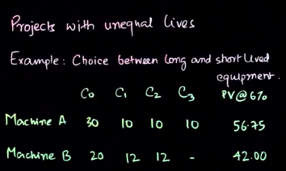

Here, PV of cost for machine A is higher than PV of cost for machine B but Machine A is going to be working for 3 years while Machine B is going to be working for 2 years only.

So, perhaps we can come up with equivalent annual cost.

So,



Clearly now, Machine A has a lower cost.

**Projects with embedded options**

Options are choices which are embedded at year 0 in a project but can be executed at a later stage of the project depending upon the economic state at that later stage of the project.

In case of projects with embedded options (which has certain probability associated with it), while arriving at NPV, we need to multiple the NPVs with the probability ratio.

Consider below example (without considering the options) , with discount rate @ 25% (Perpetuity = C/r)



Options are choices which are embedded at year 0 in a project but can be executed at a later stage of the project depending upon the economic state at that later stage of the project.

Consider below example (WITH considering the options) , with discount rate @ 25% (Perpetuity = C/r)

Unlike above example, which had a discount rate of 25%, since now we are in year 1 and going ahead, it means we are considering the success option, so the discount rate can be lowered, to say 10%.

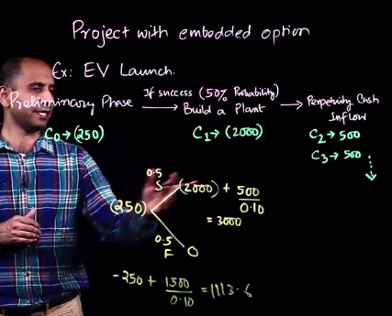

**Cost of Capital**

The cost of capital is also known as the discount rate, as it is used for discounting the future value of a project to arrive at its present value. It is also known as the required rate of return, as it is the minimum rate of return required by the investors of capital. Essentially, the suppliers of capital will not voluntarily invest their money in a project unless the return from it is equal to or greater than the return from an investment in another project with the same level of risk. Hence, the cost of capital is also called the **opportunity cost** of capital.

We need to understand the relationship between Company’s cost of capital and the project cost of capital.

Suppose, a company is running three projects as:

* Project 1 – High Risk – Market Value of 100 Cr.
* Project 2 – Average Risk – Market Value of 100 Cr.
* Project 3 – Low Risk – Market Value of 100 Cr.

And to fund the above three projects, it has financed the same as:

* Equity: 150 Cr
* Debt: 150 Cr

So, the capital structure of the company (Debt : Equity) is 1:1

A company acquires the required capital from various sources, such as by borrowing (Debt) or using funds from owners (Equity). The owners’ capital and the loans taken from outsiders together form the **capital structure of a company**.

Now, let’s try to derive a relationship between company cost of capital and the project cost of capital.

Now, considering above example,

Let’s take a look at the company

Debt = 150 Cr and Equity = 150 Cr. Debt is risk free and fixed and as such has a lower return rate. Say 12% for this example. The equity person(s) / stakeholders are running high risk and has claim only to the residual cashflows, so naturally his return rate would be higher. Say 20% for this example.

So, overall cost of capital which would be faced by company is a weighted average.

So, overall Cost of Company, (WACC – weighted average cost of capital) = 20% of (150/300) + 12% of (150/300) = 16%.

So, here cost of capital of the company = 16%.

So, we saw that the cost of capital of the company is calculated by:

Weighted percentage of Debt + Weighted percentage of Equity.

Now let’s take a look at projects

* Project 1 – High Risk – 22% returns.
* Project 2 – Average Risk – 16% returns.
* Project 3 – Low Risk – 10% returns.

Concluding again,

Equity owners are the recipients of residual profit, and debt providers receive a fixed charge in the form of interest irrespective of the profit status of the company. Hence, the risk assumed by debt providers is lower than the risk assumed by equity owners. Therefore, the cost of debt is lower than the cost of equity.

The cost of debt and equity together make up the cost of capital. The formula for calculating the weighted average cost of capital is given below:

Kc = kd*Wd + ke*We

* kd is the**cost of debt**,
* ke is the **cost of equity**,
* Wd is the **weight of debt** calculated as debt/(debt+equity), and
* We is the **weight of equity**calculated as equity/(debt+equity).

Note that the cost of capital for a company is different from the cost of capital for the projects taken up by the company.

**Determinants of Project Risk**

If the risk increases, then the debt providers will ask for a higher return, and both the cost of debt and the cost of capital will rise. This can be the case with equity providers too. The higher the risk, the higher is the return.

Determinants of Project Risk:

* Cyclicality
* Operating Leverage

Cyclicality:

Profit = Revenue – Cost

So, if the project is such that the revenue is extremely volatile, the profits are also going to be volatile and hence the cashflows are going to be volatile.

So, if a project is, say in petroleum, it is highly risky.

Concluding,

* Revenues and cash flows are highly related to up-cycles and down-cycles.
* When the economy faces a downturn, people try to cut down expenditure on unnecessary or luxury commodities. Therefore, the demand for such commodities falls. This affects both the revenue and the cash flow.
* The fall in cash flow increases the risk in the projects; hence, a higher discount rate is used in such projects in order to incorporate the increased risk.
* However, essential commodities such as food grains, edible oil, medicines, salt, sugar, etc. are not affected by the up-cycles or down-cycles in the economy.
* So, if the project is related to commodities that are affected by the up-cycles or down-cycles in the economy, then the cash flows become highly uncertain. This high uncertainty increases the project risk.

Operating Leverage:

Some operating costs are fixed, so irrespective of if the revenue is going up or down, these costs remain fixed by and large. It is good news when the revenues are going up but if the revenues are going down, it is a bad news.

Concluding,

* Operating leverage means leveraging the presence of fixed cost in a business. Hence, fixed cost becomes one of the most important aspects of operating leverage.
* Fixed cost refers to the cost that does not vary directly with the change in output (quantities of product manufactured or serviced) or revenue.
* So, if a company has a high fixed cost and high demand for output / high revenue, then the fixed cost will be distributed over a high number of output/units. And any increase in revenue will directly impact your profit margins in the same proportions. Hence, the company will benefit from operating leverage.
* However, if the fixed cost is high but the revenues are low, then the profit margin will decrease, and the company will be in a risky state. This is because the fixed cost will be divided among a fewer number of output units, which will, in turn, increase the risk of the company. Therefore, the company will suffer from operating leverage.